**Monitoring of Temperature and Light Sensor Using LIFA**

**Vatsal Shah *, Prof. Bhavin Gajjar\*\***

*IEEE Student, Student Department of Electronics & Communication Engineering, Indus University, Ahmedabad, Gujarat

** Prof. Department of Electronics & Communication Engineering, Indus University, Ahmedabad, Gujarat

***ABSTRACT: The current state of the atmosphere plays a major role in the field of agriculture, forestry, marine, utility companies etc. Due to the recent advancements in technology functionality of many home appliances is being controlled based on the conditions of weather. In the industry, plant is being monitor and controlled continuously and data is saved in a file with time and date. The program is designed using LabVIEW. In this we use an Arduino board with LabVIEW interfacing different sensors placed in local environment to measure temperature, intensity of light. This paper involves the measuring and the monitoring of the temperature and intensity using Virtual Instrumentation-LabVIEW.***

***Keywords: Temperature, intensity, Arduino, LabVIEW.***

**I. INTRODUCTION**

The temperature is a numerical measure of hot and cold in a body that is in its own state of internal thermal equilibrium. Its measurement is by detection of heat radiation or particle velocity or kinetic energy, or by the bulk behaviour of a thermometric material. Temperature parameter is an important in all fields of natural science, including physics, geology, chemistry, atmospheric sciences and biology.

Arduino is a single-board microcontroller, intended to make the application of interactive objects or environments more accessible. It's an open-source physical computing platform and a development environment for writing software for the board. Arduino can be used to develop interactive objects, taking inputs from a variety of switches or sensors, and controlling a variety of lights, motors, and other physical outputs. Arduino has some advantages for educational and interested recreational over other systems like Inexpensive, Open source and extensible software, extensible hardware [2].

LabVIEW (short for Laboratory Virtual Instrument Engineering Workbench) is a system-design platform and development environment for a visual programming language from National Instruments. The software is perhaps the most important component of the system. The main routine, or VI, provides a front panel interface that allows the operator to control and monitor the system. It calls to perform functions that gather Analog input, send Analog output.

The front panel is what allows the operator to control and monitor the process. It includes software controls and indicators that mimic physical controls such as buttons, sliders, LEDs, and charts. The block diagram is a graphical representation of the underlying software program. It consists of icons that represent typical programming elements such as constants, variables, subroutines, and loops.

The LabVIEW Interface for Arduino (LIFA) allows users to control sensors and acquire data through an Arduino microcontroller using the graphical programming environment LabVIEW. Arduino microcontroller acts as an I/O engine that interfaces with LabVIEW VIs through a serial connection. This helps to move information from Arduino pins to LabVIEW without adjusting the communication, synchronization. Using the common Open, Read/Write, Close convention in LabVIEW, we can access the digital, Analog, pulse-width-modulated, I2C, and SPI signals of the Arduino microcontroller. The program measures the temperature and humidity from the process [3].

**II. INTERFACING OF LM35 & PHOTOCELL TO ARDUINO**

Temperature measurement is performed by an integrated circuit temperature sensor LM35 [6]. The output voltage of sensor is linearly proportional to temperature with a gradient of 10mV/ºC and able to operate in the range -55ºC to+150ºC with an accuracy of ± 0.5ºC. These make LM35 good choice for patient temperature monitoring. The LM 35’s low output impedance, linear output, and precise inherent calibration make interfacing to readout or control circuitry especially easy. It can be used with single power supply, or with plus and minus supplies. As it

draws only 60 μA from its supply, it has very low self-heating, less than 0.10C in air. The LM 35 sensor has three terminals, the first terminal is connected to 5 Volts Vcc supply and the third terminal is grounded. The centre terminal is terminal two and this is the output terminal Vout that gives the output voltage corresponding to the sensed temperature. The centigrade temperature is converted to Fahrenheit temperature and displayed [4, 6].LM35 is a transducer or temperature sensor that converts heat energy into electrical energy i.e. it senses the temperature and gives an output voltage corresponding to the sensed temperature.

Light Intensity measurement is performed by the sensor Photocell [ ]. This sensor module converts relative intensity to voltage and can be used in lighting monitoring application. It able to operate in the range -30ºC to+75ºC. The Photocell’s high sensitivity and high stability make interfacing to readout or control circuitry especially easy. It can be used with single power supply, or with plus and minus supplies. The red terminal is connected to 5 Volts Vcc supply and the blue terminal is grounded. The centre terminal white terminal two and this is the output terminal Vout that gives the output voltage corresponding to the sensed temperature [5, 7].

Temperature Sensor

Photocell

Arduino

LabVIEW

Figure 1: Block diagram of the system

The Fig (1) shows the hardware interfacing of LM35 and Photocell sensors to the Arduino board.

**III.MODELING AND SIMULATION OF THE SYSTEM**

The program has been developed for sensing the voltage from sensor, process data and display the room temperature and humidity. The software language LabVIEW is used to develop the program. LabVIEW uses dataflow programming, where the flow of data through the nodes on the block diagram determines the execution order of the VIs and functions [8]. The block diagram contains this graphical source code, also known as G code or block diagram code. Front panel objects appear as terminals on the block diagram [9].

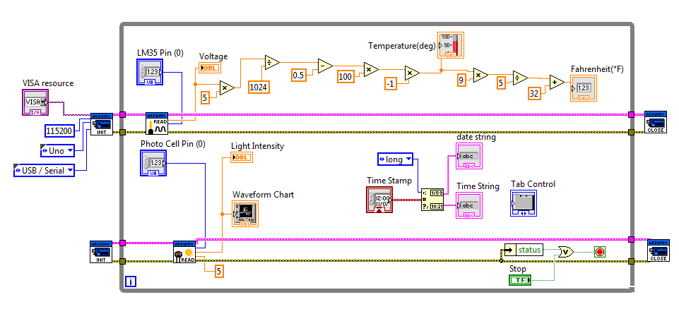

**Fig 2: Block diagram of Temperature and Intensity measurement**

The output of the LM35 sensor is connected to the pin A0 of the Arduino. Using LIFA (LabVIEW Interface for Arduino) the Arduino Uno board is interfaced to LabVIEW. And the input of Photocell is connected to the pin A1 of the Arduino. In the very first step Arduino was initialized. The temperature sensor reads the temperature of the particular environment, which we want to measure and converts the temperature into corresponding electrical signal. Then the Analog value is converted into digital by means of Analog to digital converter in order to read microcontroller. From the Arduino resource by using Analog read.vi we can read the values of temperature and humidity in terms of the voltage. To end the process we had to place the Arduino close for the process. The temperature is measure in Degree Celsius (°C) and Intensity is measured with respect to perfect candela.

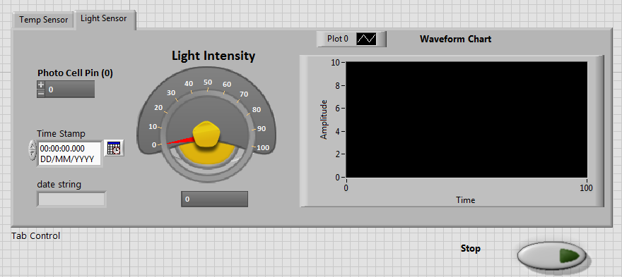**IV.RESULTS AND DISCUSSION**

Fig 3: Front panel of the Humidity measurement

We have obtained observations of temperature and intensity from the Arduino blocks in LabVIEW. This inexpensive system is designed for Industries, having Analog I/Os to measure and record the processes in industries. This work has considered two important parameters to measure temperature and intensity as being mostly measured parameters in industries. The presented system can be useful for studying behaviour of intensity and temperature even at remote location.

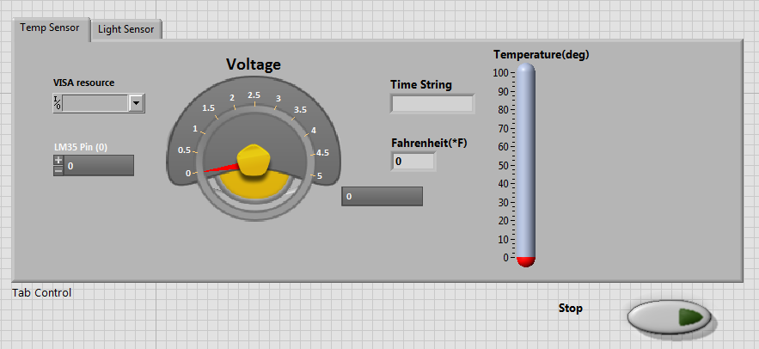

Fig 4: Front panel of the Temperature measurement

**REFERENCES**

1. www.arduino.cc
2. www.ni.com
3. T.Bheema lingaiah, D.Hanumesh Kumar, C.Nagaraja, Solomon Woldetsadik “Development of Humidity and Temperature Measurement Instrumentation System using LabVIEW”, IJAREEIE Journal
4. Data sheet of LM 35 Temperature Sensor
5. Moumita Sahoo “An Approach to LabVIEW based Temperature and Relative humidity monitoring system”, ACEEE Journal
6. Gary W. Johnson, Richard Jennings, “LabVIEW Graphical Programming”, 4th ed. McGraw-Hill.
7. Somesh Katiyar, Gaurav Sharma and Dr. Ashavani Kumar “Automated Control System: Using Lab VIEW, Android”, IJRSA Journal
8. K P J Pradeep, K Sai Prasad Reddy, D Hanumesh Kumar, K Nagabhushan Raju, C Nagaraja“Monitoring of Temperature and Humidity Using LIFA”, IJIEASR Journal